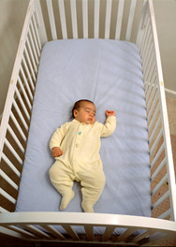

Photo courtesy of NICHD at http://www.nichd.nih.gov/sids/

